Workaround for MOSAIQ Online Help Display

# Purpose

There is a known issue with MOSAIQ 2.81 that causes the Online Help not to display on computers running the latest version of Windows 10 Pro (21H1). Online Help is the in-app documentation accessed from the **Help** tab:

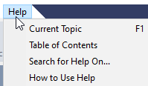

The bug is as follows:

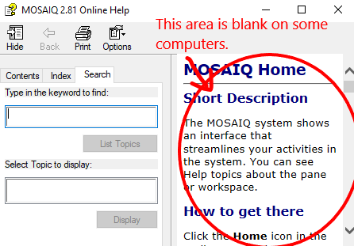

The bug is fixed in MOSAIQ 2.83, but until we upgrade, we’ll have to settle for a copy of the HTML Online Help on the desktop. Here’s how to set that up.

# Steps

1. Navigate to the MOSAIQ program folder on your PC. You can right-click the desktop shortcut and select **Open file location**.

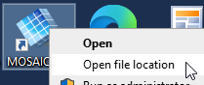

1. Copy the file mosaiq.chm.

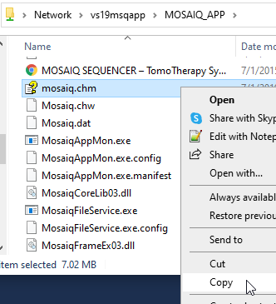

1. Paste the copied file to your Desktop.

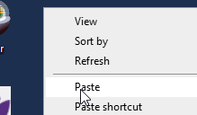

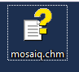

1. You obviously won’t be able to open the help file for the currently open topic in MOSAIQ.



But all other functionality is there, including search.

